LHC- - - 1999-09-22
Test report
BGI flange leak tightness tests with HELICOFLEX seals
Abstract: Problems were encountered to seal leak tight the rectangular LHC BGI flanges. A series of tests were made with a defined surface roughness, variable compression of standard (HN) and so-called Delta (HNV) seals in order to find a solution. This report summarises the tests made.
Prepared by :  G. Schneider (BE-BI)  M. Hamani (BE-BI)  C. Rinaldi (ALTE AD) | Checked by : | Approved by :

Contents
1. Introduction 3
2. Material TEsted 3
2.1 Seals 3
2.2 Flanges 4
3. Tests Made 7
3.1 Flange Assembly 7
3.2 Bakeout assembly 7
3.3 Leak tests 7
3.4 HNV Seal 8
3.5 HN Seal 9
3.6 HNV Seal with additional 0.3 mm spacer 9
4. Experience during the assembly of the LHC BGI flanges 10
5. Conclusion and outlook 11
6. Acknowlegements 11
7. References 11

Introduction

The LHC BGI (LHCBGIH_0001) rectangular flanges as seen in Figure 1 were found leaking in the LHC Christmas Break 2011/2012.
It was challenging to make these flanges leak tight. In order to assure the leak tightness of the BGI flanges after the Long Shutdown 1 (LS1), a series of tests were made on a dedicated pair of flanges.
The surface roughness was inspected. The Helicolflex seals were of type HN and delta (HNV). The assemblies were tested both at room temperature and baked up to 200 °C.
Seals of type HNV were used for BGI assemblies before the LS1.
The instruction how to prepare the surfaces and how to mount the seals can be found in TECHNETICS Group FICHE TECHNIQUE 921-045 REV.B, St. Etienne, France.
Bakeout cycles were made in order to check if leaking seals become leak tight during or after the bakeout using the hypothesis that the aluminium sealing surface material becomes more ductile and therefore “marries” better with the surface. The second motivation was to check on leak tight seals if bakeout temperatures up to 200 °C have an impact on the leak tightness of the seal.

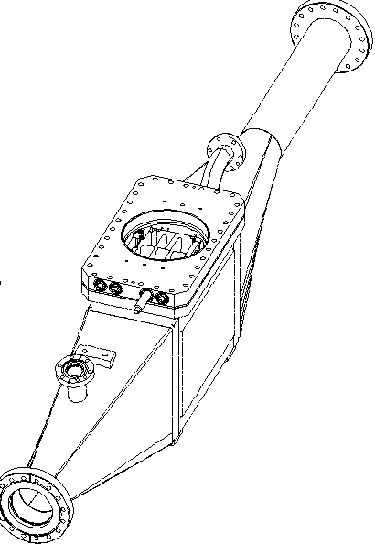
Seal with problematic leak tightness
                - Figure 1: Drawing of LHC BGI

Material TEsted

Seals
The following seals were tested made of a stainless steel Nimonic circular spring with aluminium coating. The part reference, order number, compression and nominal compression force can be seen in Table 1.

                - Table 1: Part number, order numbers and compression details as found in Technetics technical information

Seal type | Part Reference | EDH Order | Compression[] [mm] | Compression Force [N/mm]
HNV | Helicoflex~HNV~200~Rectrangulaire~ 298~164~24.5~4.9 Aluminium A5  731 822 009000 | 4805258 | 0.9 +/- 0.1 | 140
HN | Helicoflex seal HN 200 De Forme - Aluminium - Nimonic - 298.12 x 307.8 x 164.12 x 173.8 x 24.56 x 29.4 Tore 4.84  848420000000V | 5450025 | 0.9 +/- 0.1 | 230

Flanges
The flange as mounted on the instrument can be seen on drawing SPSBIPMV0012. Two simplified versions were made without feedthroughs and without window in a thickness of 18 mm with 316 LN stainless steel from the CERN stores as per SCEM 44.59.32.620.8. One of the used flanges had a CF-40 pumping port. The flange surface preparation was made with a dedicated tool that allowed the direction of the sealing to be followed including the corners. The result of the surface preparation can be seen in Figure 2.
The surface roughness of the test flanges were measured in 22 positions and reported in EDMS 1349089. One flange was measured without contact on a VEECO – NT 3300, see Figure 3. Both flanges were then re-measured using a MITUTOYO SJ-301 measuring system.
The result was in all cases a surface roughness R_{a} of about 0.4 microns with a variation of about +/- 0.1 microns. This is on the lower recommended surface roughness [¹].

A 3.9 mm thick spacer as seen on drawing SPSBIPMV0009 was used between the flanges both for the HNV and HN seals, see Figure 4. Additionally, a total of 12 grooves of 5x0.5 mm depth were machined into the spacer, see Figure 5, in order to facilitate the leak testing. The cross section of the assembly can be seen in Figure 6.

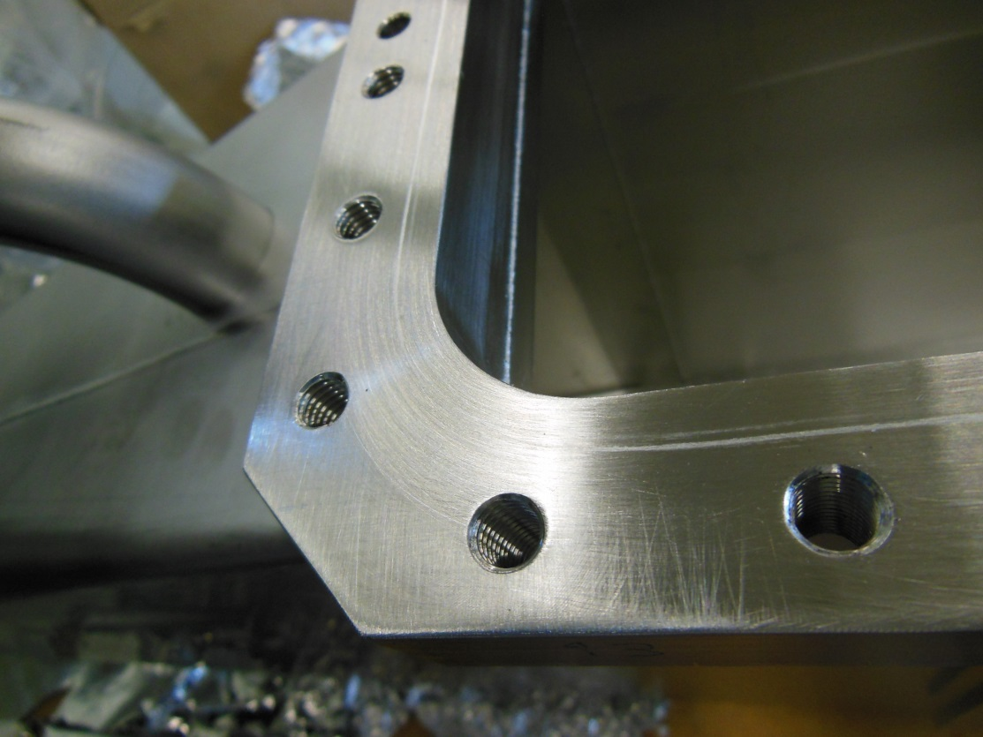
                - Figure 2: Seal surface after preparation.

                - Figure 3: Veeco surface measurement machine

                - Table 2: Measured surface roughness
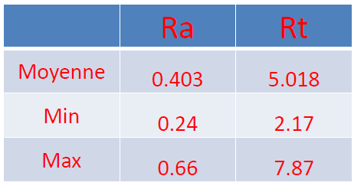

                - Table 3: Recommended surface roughness [¹]
Seal Type | Flange Surface Roughness (Ra) in µm
Seal Type | Optimum | Acceptable Range
HNV | 0.6 | 0.2 to 0.8
HN | 0.8 | 0.4 to 1.0

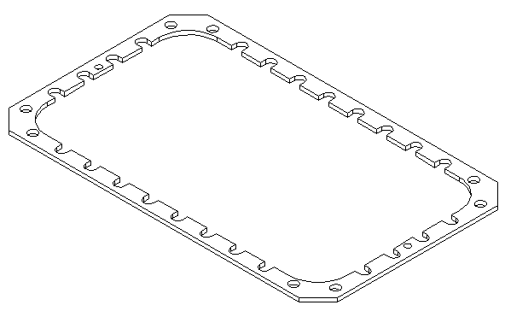
                - Figure 4: Spacer as per drawing SPSBIPMV0009

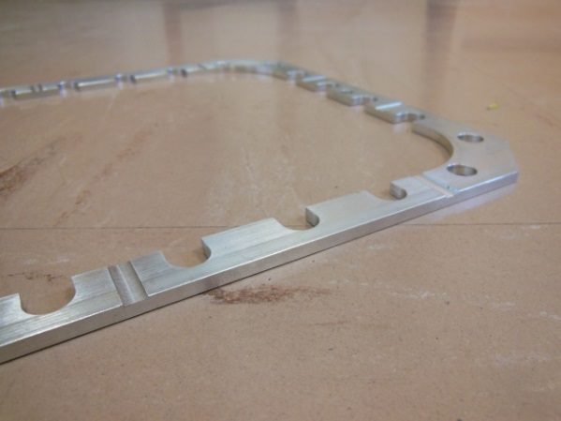
                - Figure 5: Grooves of 5x0.5 mm were machined in the spacer

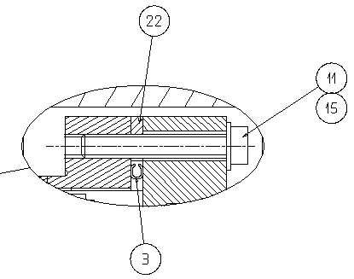
                - Figure 6: Cross section of the flange assembly

Tests Made

Flange Assembly
From experience, conflat flanges are best tightened starting with a “cross” shape and then progressively tighten the flange. We applied a similar procedure for the HN and HNV seals.

Both HN and HNV flanges were tightened with the following sequence:
- Place the seal
- Position the facing flange
- Add all silver coated screws
- Tighten all screws by hand without tools
- Tighten one screw at each corner to 2 N/m
- Tighten all screws to 2 N/m in a circle
- Increase the force by 2 N/m per circle up to 10 N/m
- Tighten the screws until the flanges are touching each other at an estimated 15 N/m.

Bakeout assembly
A heating tape was installed around the flange perimeter as seen in Figure 7 and Figure 8.
A total of 8 thermocouples were installed in order to see the temperature variation on the flange assembly. The flanges were then covered by glass fibre thermal insulation. The temperature variation of the flange measured with 8 thermocouples at various locations was within +3/-2 °C around the set temperature of 120 °C.

Leak tests
All leak tests were made without the bakeout material. The flanges were put in a plastic bag and sealed with aluminium tape in order to assure a helium atmosphere close to 100 %.
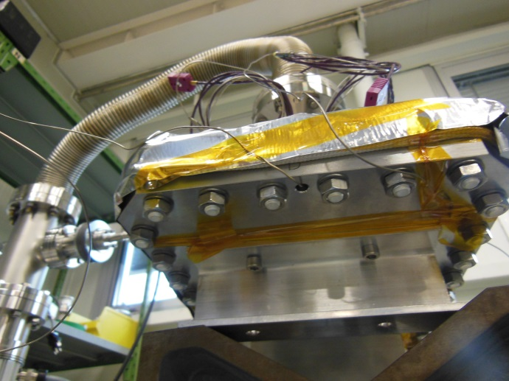  Figure 7: Installation of thermocouples below the flange | 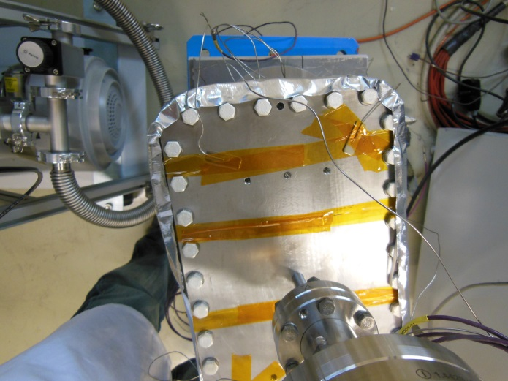  Figure 8: Installation of thermocouples above the flange

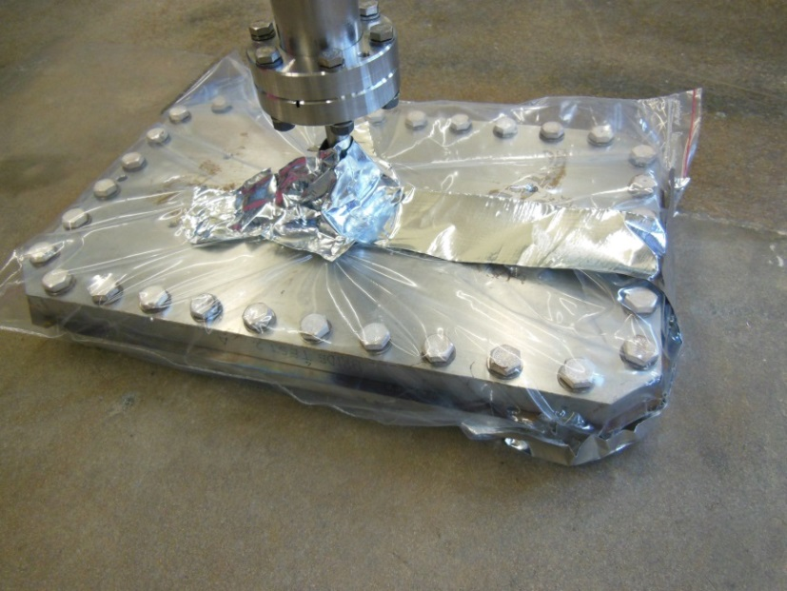
                - Figure 9: Flange in leak test bag

HNV Seal
A HNV seal was mounted as proposed by the seal manufacturer with a compression of 0.9 mm. The seal was then leak tested. The leak rate was 1.5*10⁻⁷ mbar.l/s.
The seal was then baked for 24 hours with a temperature increase and decrease of 40 °C/h. The reason why we started the bakeout with the leak was that we assumed the leak would close due to the higher ductility of the aluminium coating of the seal after the bakeout. Total 2 seals were tested. The result can be seen in Table 4 for the first seal and Table 5 for the second seal. The sensitivity of the leak test was always 1.2*10⁻¹⁰ mbar.l/s.

                - Table 4: Leak rates before and after bakeout of the HNV flange assembly with the first seal tested
 | Leak rate after bakeout  [mbar.l/s] | Temperature  [C]
Before bakeout | 1.5*10⁻⁷ | -
First bakeout | 3.1*10⁻⁸ | 110
Second bakeout | 7.2*10⁻⁸ | 120
Third bakeout | 4.5*10⁻⁷ | 180

                - Table 5: Leak rates before and after bakeout and cool down of the HNV flange assembly with the second seal tested
 | Leak rate  [mbar.l/s] | Temperature  [C]
Before bakeout | 1.0*10⁻⁷ | -
First bakeout | 2.3*10⁻⁸ | 110
Second bakeout | 2.0*10⁻⁷ | 180

HN Seal
The HN seal was mounted as proposed by the seal manufacturer with a compression of 0.9 mm. The seal was then leak tested. No leak was observed with a sensitivity as given in Table 6. The seal was baked for 24 hours with a temperature increase and decrease of 40 °C/h.

                - Table 6: Leak rates before and after bakeout and cool down of the HN flange assembly
 | Leak rate  [mbar.l/s] | Temperature  [C]
Before bakeout | <2*10⁻¹¹ | -
First bakeout | <1*10⁻¹¹ | 120
Second bakeout | <5*10⁻¹² | 200

HNV Seal with additional 0.3 mm spacer
The HNV seals were compressed by 0.9 mm (4.8 mm – 3.9 mm) when assembled. After disassembly, we measured typically a thickness of 4.00 to 4.05 mm, which implies a spring back of about 0.12 mm. We assumed that the seals might be over-compressed. Therefore, we launched a test with a reduced compression by 0.3 mm, hence a compression of 0.6 mm. This was reached by adding 0.3 mm thick shims around the seal, see Figure 10. No leak was measured with a sensitivity as given in Table 7.

                - Table 7: Leak rates before and after bakeout of the HNV flange assembly with a 0.3 mm thick additional spacer
 | Leak rate  [mbar.l/s] | Temperature  [C]
Before bakeout | <2*10⁻¹⁰ | -
First bakeout | <2*10⁻¹¹ | 200

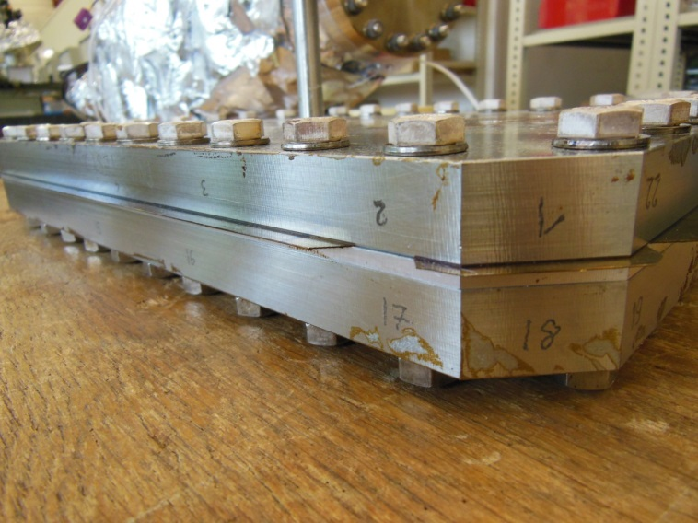
                - Figure 10: HNV seal test with reduced compression and shim addition

Experience during the assembly of the LHC BGI flanges
The 4 LHC BGIs were equipped with HN seals before re-installation towards the end of the Long Shutdown 1. The standard spacer as per drawing SPSBIPMV0012 with leak check grooves was used. The surfaces were prepared with the above procedure and documented in EDMS 1349089. The typical roughness Ra for the flanges installed is between 0.5 and 0.6 mircons.
Three of the HN seals were leak tight the first time after mounting and one leaking. Scratches were found on the sealing surface of the leaking flange, see Figure 11 and Figure 12, provoking a leak in the 10⁻⁷ mbar.l/s range. After repair of the surface, the flange was leak tight using an HN seal.

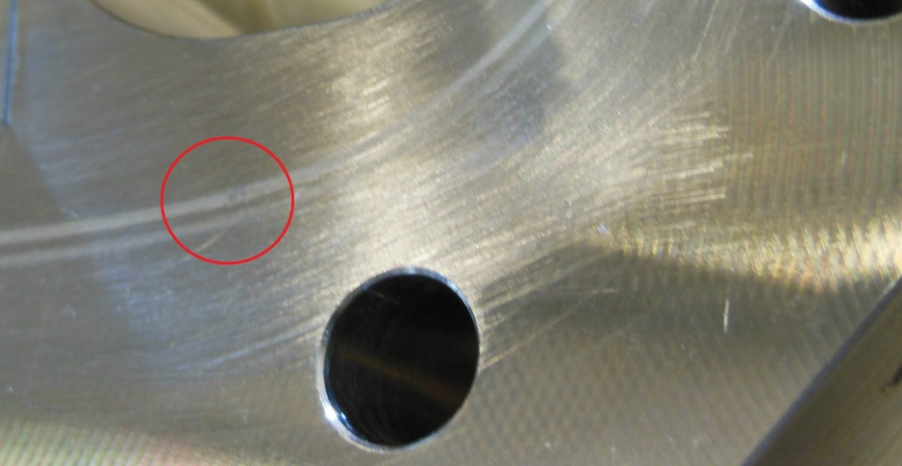
                - Figure 11: Scratch on sealing surface

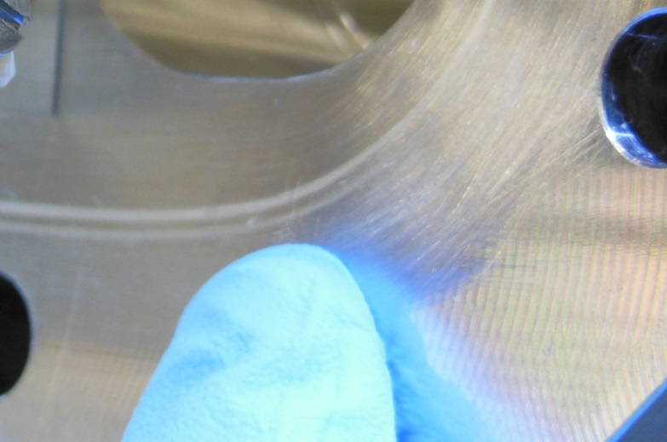
                - Figure 12: Scratch on sealing surface

Conclusion and outlook
The LHC BGI sealing system as designed seem to work with HN seals of type Helicoflex seal HN 200 De Forme - Aluminium - Nimonic - 298.12 x 307.8 x 164.12 x 173.8 x 24.56 x 29.4 Tore 4.84 - 848420000000V. The sealing surface need to be prepared carefully and protected at all times. A bakeout up to 200 °C seems to be no problem.
The HNV seals of type Helicoflex~HNV~200~Rectrangulaire~ 298~164~24.5~4.9 Aluminium A5 - 731 822 009000 work with a reduced sealing compression of 0.6 mm instead of the manufacturer proposed 0.9 mm. The proposed 0.9 mm compression for the HNV seals seems to be problematic.
Further investigations could be made both for the HN and HNV seals:
- Optimisation and tolerance of the compression
- The spring back
- Maximum temperature
- Tolerance of the surface roughness

Acknowlegements
Thanks to Jerome Chaure for the technical discussions and to the members of TE-VSC-LBV for their leak test, bakeout and pumping support. Thanks to EN-MME-MM for the measurements of the surface roughness.

References

Technetics Technical Information, Helicoflex, SMA 500 FE 2911

